CARE Compass
Helping Navigate the Later Stages of Dementia

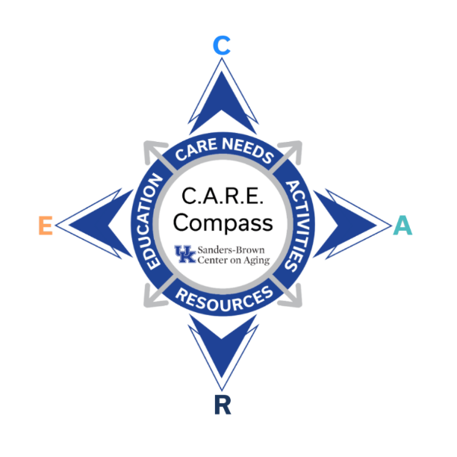
Memory Boxes


This project was made possible by a generous gift.
The goal of the program is to help provide tools and information so that you can navigate the later stages of dementia. We hope that you find these videos and resources to be helpful and encouraging.

This program is designed to be a guide only for the compassionate care and support of your loved one and is not medical advice. If you have questions or concerns, always check with your doctor.

We also want to acknowledge that late-stage dementia can look very different from person to person. Sometimes the ideas we share may not work or work for a short time. That is okay. No one person is alike, and what works today may not work tomorrow. We hope to provide tools that can be options for you to try.

This guide contains links and other resources that may not be provided by the presenter but are added to the guide to provide additional information and support.

Memory Boxes

Memory boxes are a meaningful way to connect with a person with dementia. They are a collection of familiar objects that can evoke positive memories and stimulate the senses.
To create a memory box, start by choosing a container to hold the objects. It can be anything from a shoe box to a basket, tackle box, cardboard box, or tin can- it can be anything that fits your theme.
- Think about what is important to your person to help you select a theme
- Think about what objects will help remind the individual of happy times, items that will connect them with their past.
- Focus on items that have different textures, play music, are objects that have something to look at, items with a scent. Sensory engagement can be soothing or stimulating.
- Some people may be able to explore the memory box on their own-if so, make sure they can open the box easily and that the objects are safe to handle.
- Memory boxes are also great ways to initiate in conversation at home or in a facility
- Use statements like “I remember when we would go to baseball games together” or “I always enjoyed baking pies with you”
- If your loved one shows no interest, it is okay to stop and try again at another time
- Be flexible and responsive to your oved one’s mood and body language
- Be creative and enjoy connecting with your loved one

Examples of boxes:
- Quilting/sewing - in a basket
  - Objects – fabric squares, thimble, pin cushion, quilt photo album, small baby quilts, potpourri sachet
  - Activity – sorting fabric squares, laying out a quilt pattern, cutting fabric

- Fishing – in a tacklebox
  - Objects – any lure without a hook, weights, bobbers, pictures of caught fish, rod and reel pen, map of the lake
  - Activity – sorting lures or bobbers, going fishing game with magnets

- Christmas
  - Objects – ornaments, popper crown, teacup and saucer, tea bag, peppermint candies, music CD, Christmas cards, Christmas recipes
  - Activity – peppermint hand lotion, eat Christmas cookies/drink tea, hang ornaments on a small tree

- Baseball
  - Objects – baseball cards, glove, peanuts, pennant, baseball, hat, stadium book, memorabilia of favorite team, info on famous baseball players, movies about baseball
  - Activity-eat popcorn together or shell peanuts, sing take me out to the ball game, look through baseball cards, watch a game on tv or listen to on the radio

- Travel
  - Objects- photographs of past trips, maps, small plane or train, memorabilia from trips
  - Activity-use map to locate different cities, go through photos together, remanence about different places they have been

- Garden
  - Objects- garden gloves, seed packs, small garden tools, fake flowers, books about flowers or insects, a bag or box of dirt
  - Activity-look through images, match seed packets or sort them, play in the dirt – let them put fingers in the dirt, arrange flowers, talk about recipes made with vegetables grown

- Music
  - Objects-sheet music, small instruments or photos of instruments (kazoo, tringle, maraca) cd or other way to play music, String or ribbon
  - Activity – listen to music – play along, wave ribbon to the music, sway, dance

- Life Review
  - Objects-gather items that remind them of things they have accomplished and enjoy doing
  - Activity- reminisce about their life share the stories they have shared in the past

