SAVE the DATE
Stroke Translational Research Advancement Workshop (STRAW)
April 16-17, 2026
Lexington, KY

This meeting regularly attracts researchers and clinicians interested in stroke across the Commonwealth and throughout the USA. STRAW VII: New Advances in Stroke Research will focus on a translational approach to stroke and related cerebrovascular diseases. Topics will include new insights into novel approaches to pharmacotherapies for cerebrovascular diseases, as presented and discussed by clinical and basic scientists. This year’s speakers include Drs Walter Lowe (Neuroprotection strategies for ischemic and hemorrhagic stroke), Paul Sanberg (Intellectual Property for Translational Sciences), Lisa Wruck (Post-Stroke Cognitive Impairment) and Patrick Fillingham (Predicting cerebral vasospasm after subarachnoid hemorrhage).
As per tradition, the meeting will have no registration fee and will also include an optional excursion in the ‘land of horses and bourbon’, facilitating opportunities for networking with like-minded research scientists.

Location
Embassy Suites by Hilton Lexington Green

Agenda
Tentative Schedule

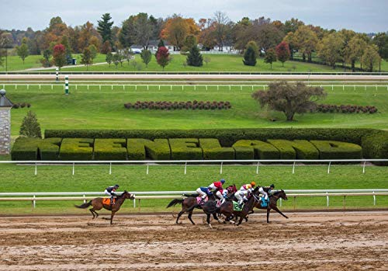
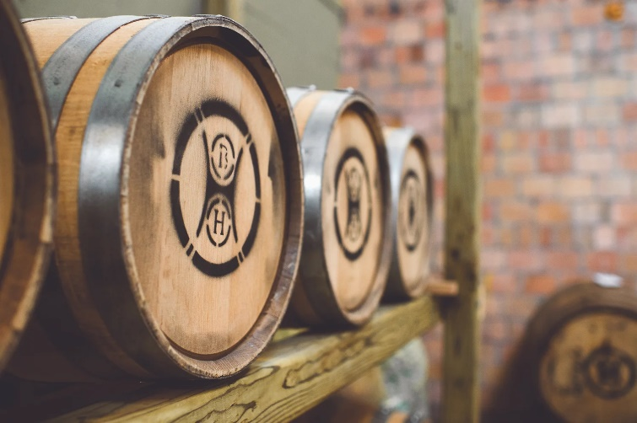

https://catss.med.uky.edu/workshop

