****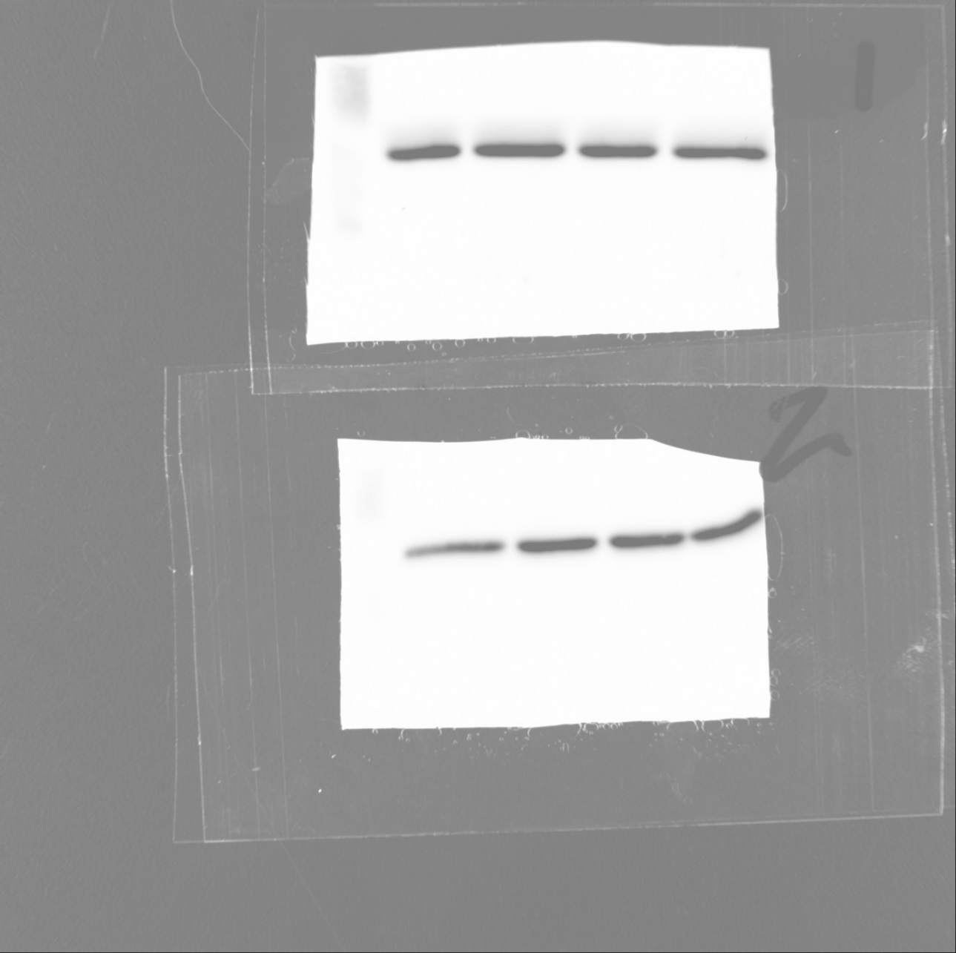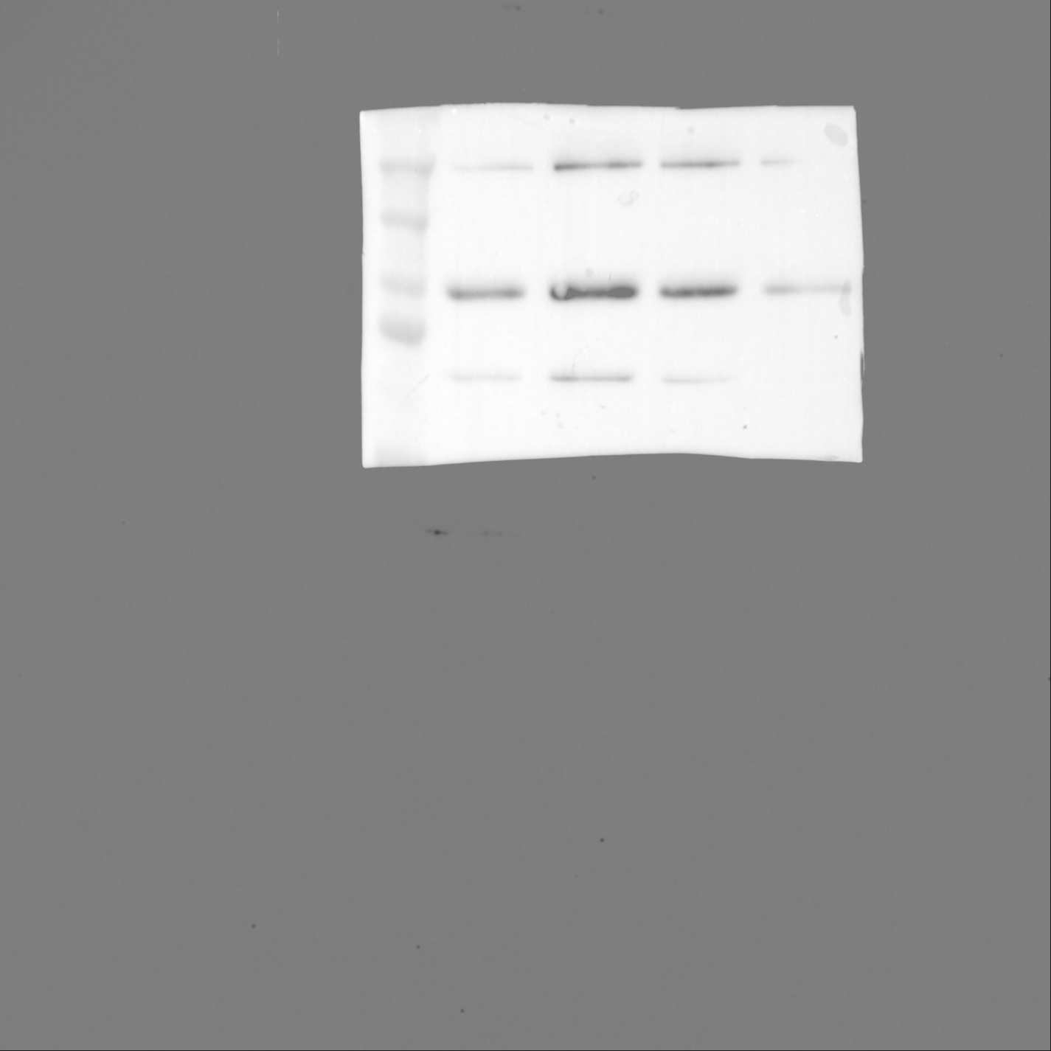

250

150

75

100

**Human subcutaneous adipocytes Figure 1A raw data**

**WB: GAPDH**

**WB: IR**

SM21

PB28

Untr

AG205

**Combined data quantification of primary adipocytes**



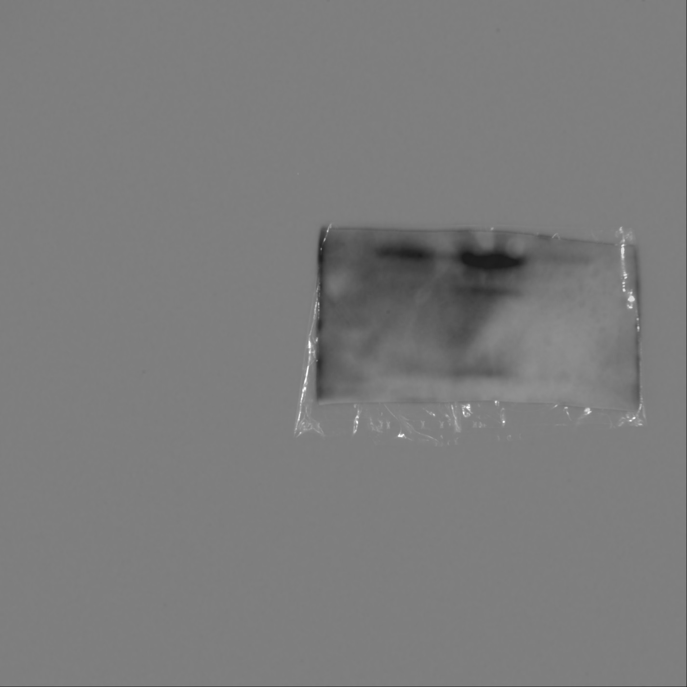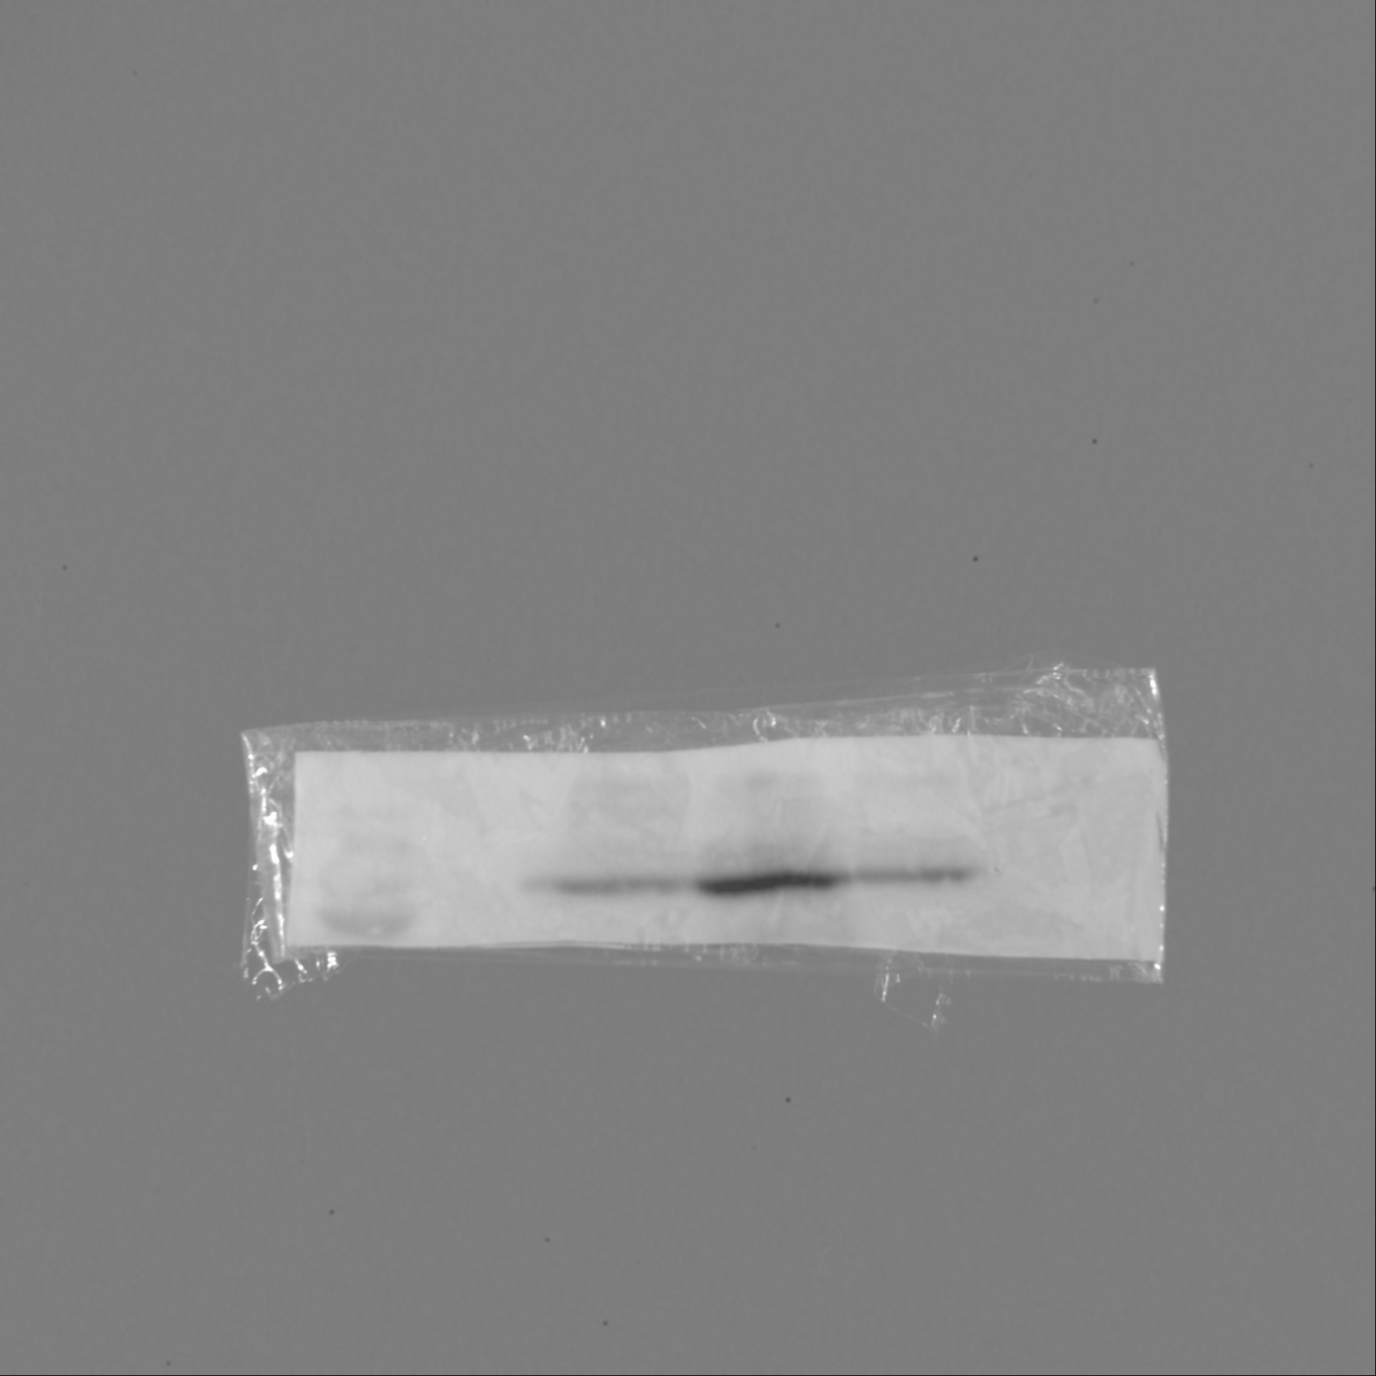****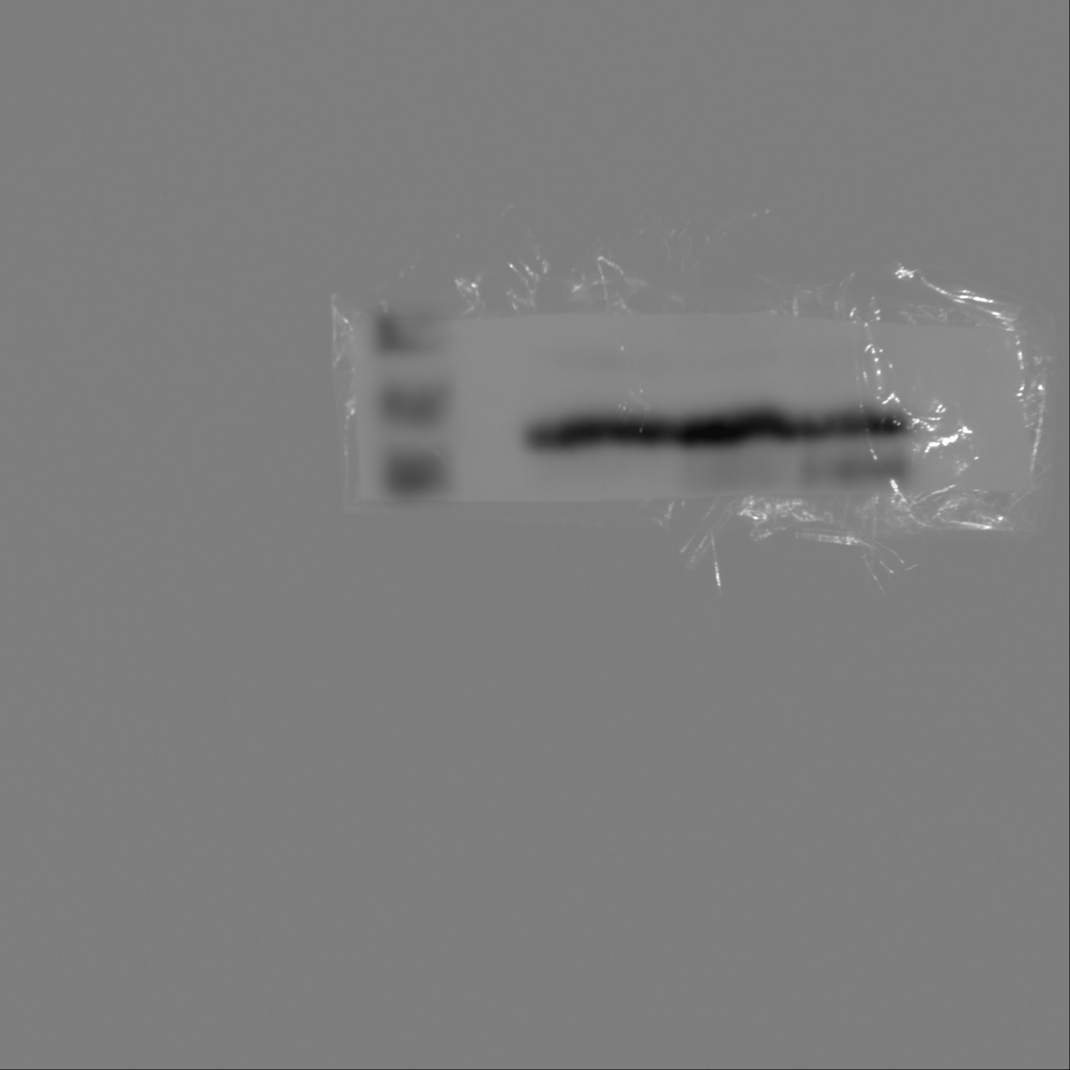

**WB: PGRMC1**

**WB: GAPDH**

**WB: IR**

**Human subcutaneous adipose tissue samples Figure 1C raw data**

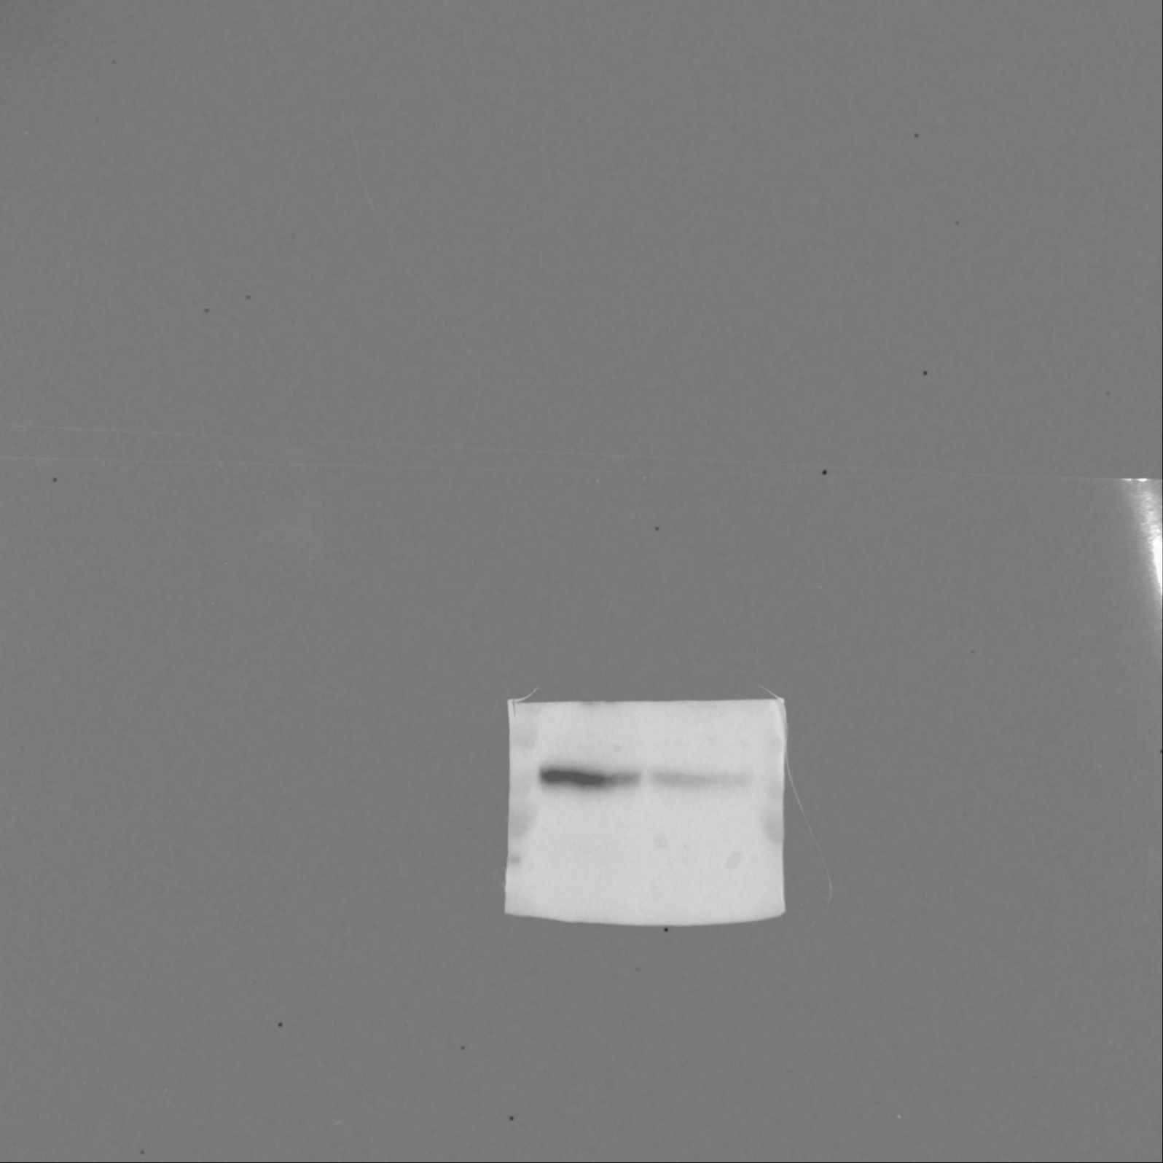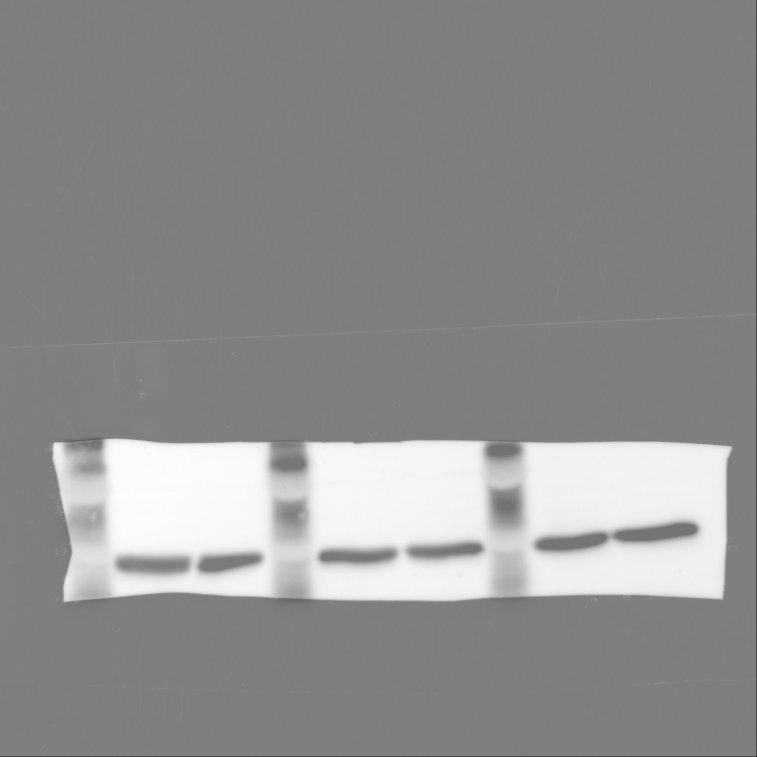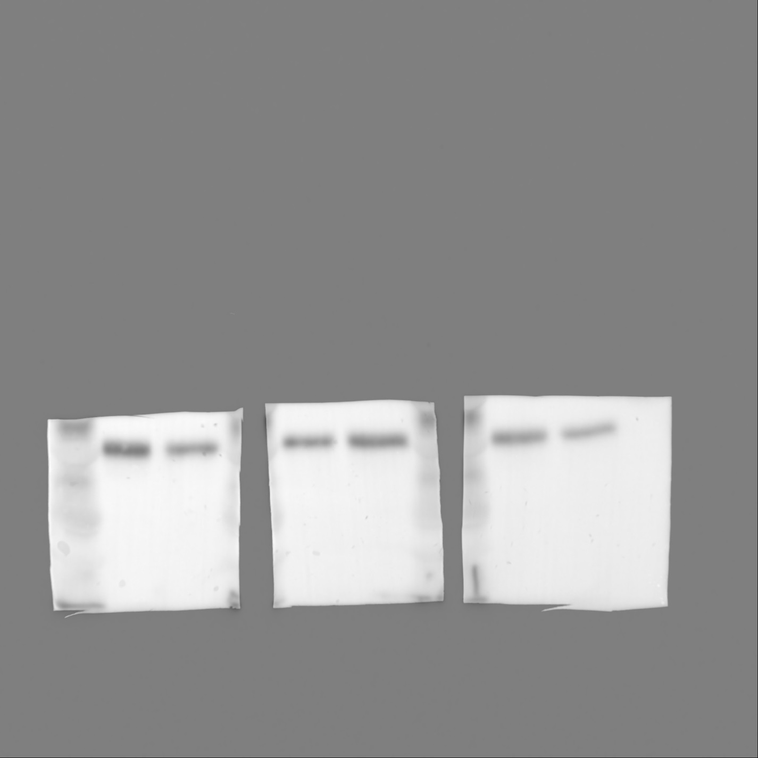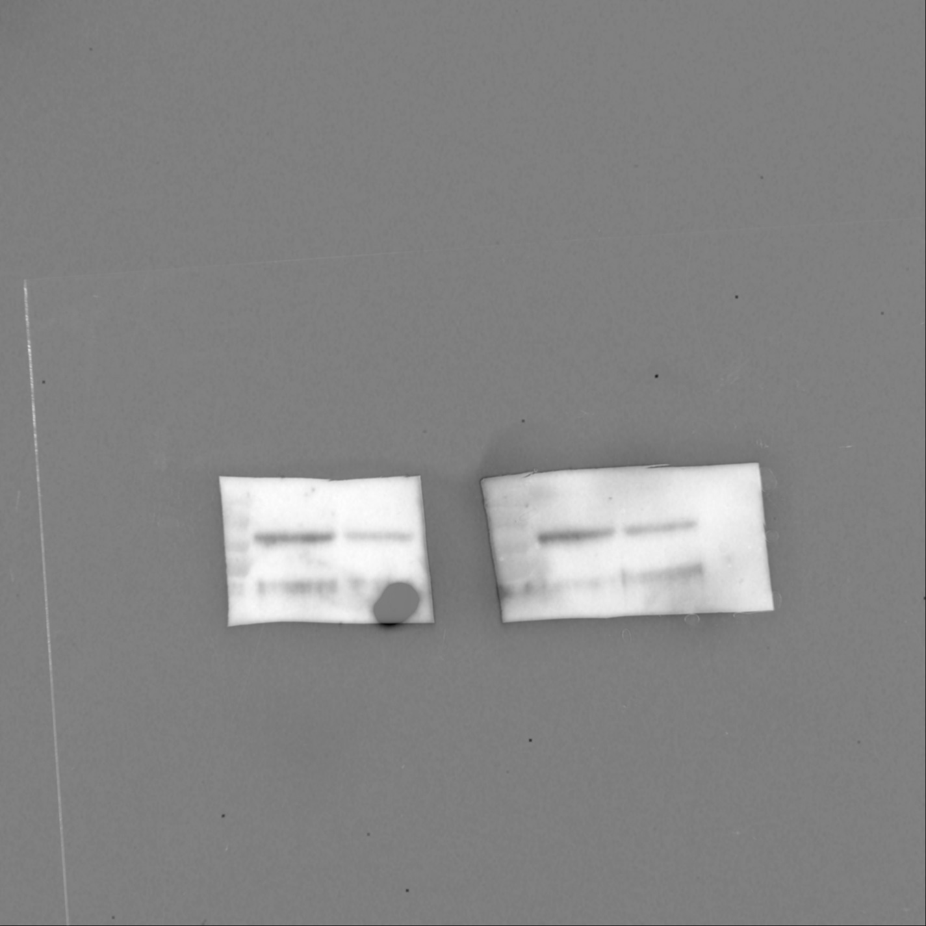

100

75

**3T3-L1 and Rat SVF Figure 2A-B raw data**

**3T3-L1**

**WB: IR**

**untreated AG205**

**3T3-L1**

**WB: GAPDH**

**untreated AG205**

**RAT**

**WB: GAPDH**

**untreated AG205**

**RAT**

**WB: IR**

**untreated AG205**



**3T3-L1 co-immunoprecipitation Figure 2C-D raw data**

**IP: IR**

**WB: IR**

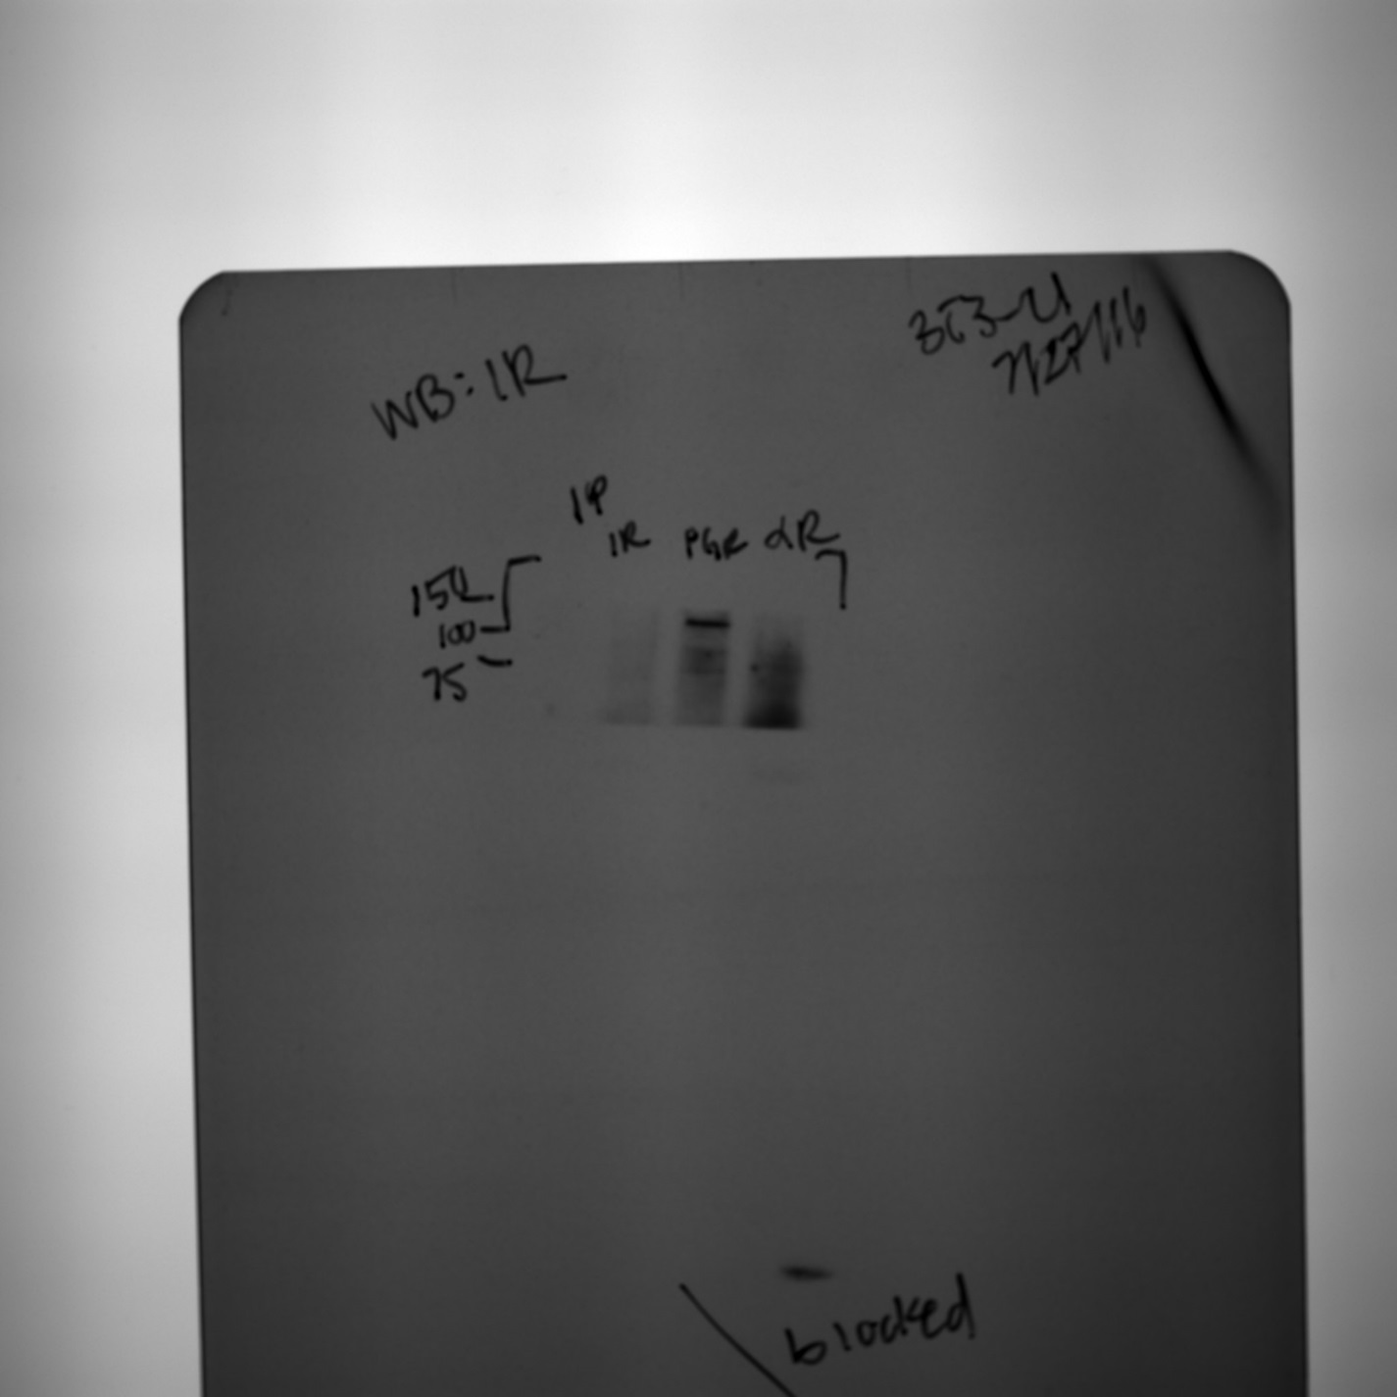

**IP: PGRMC1**

**WB: IR**

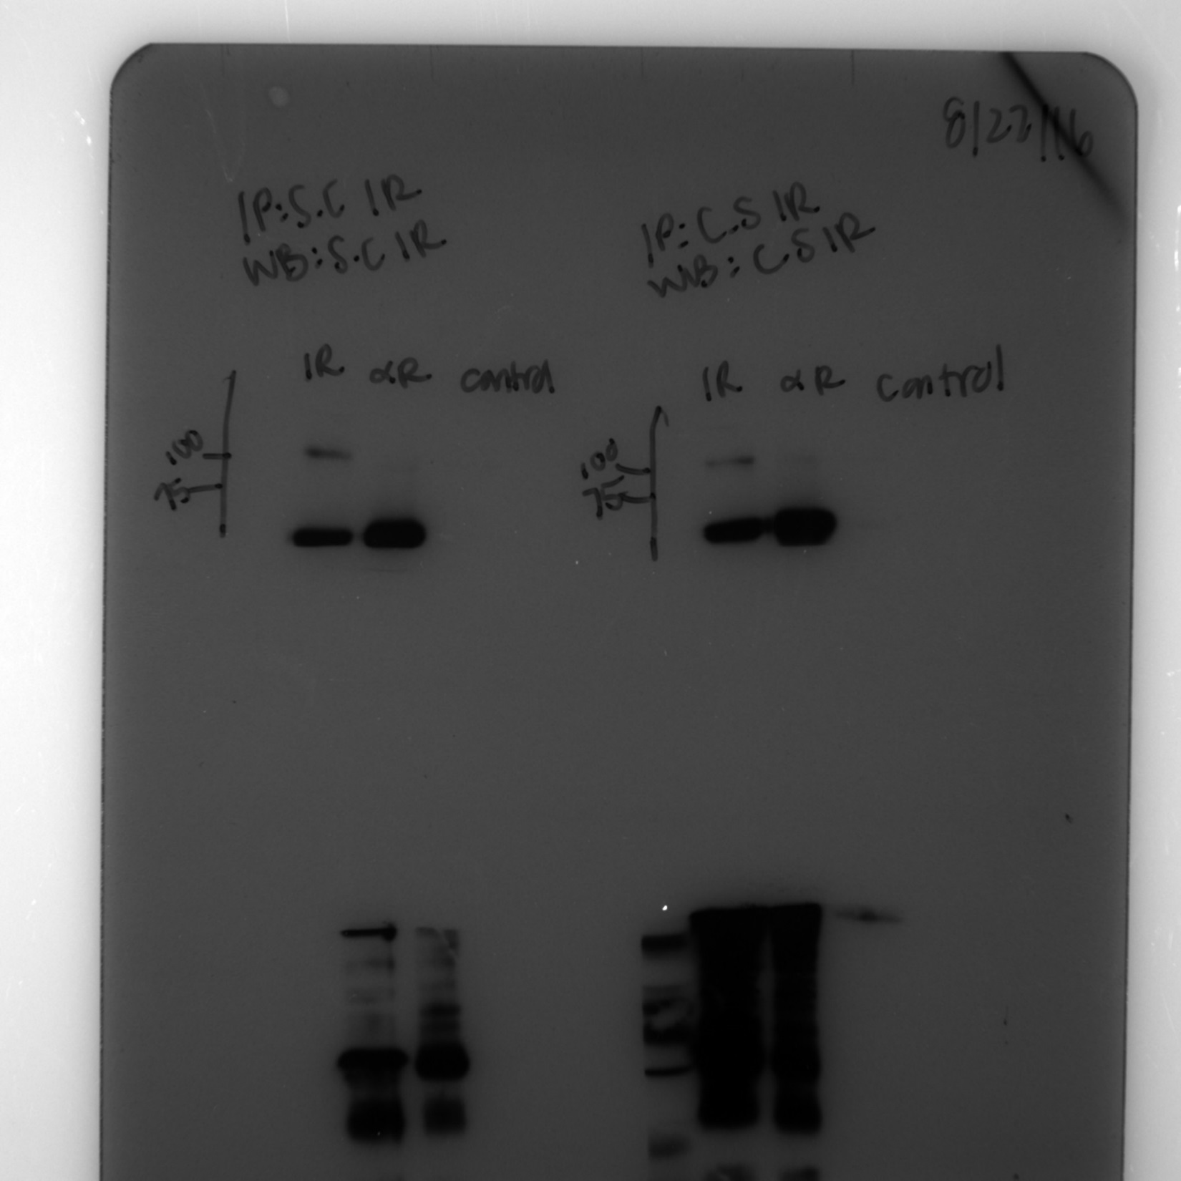

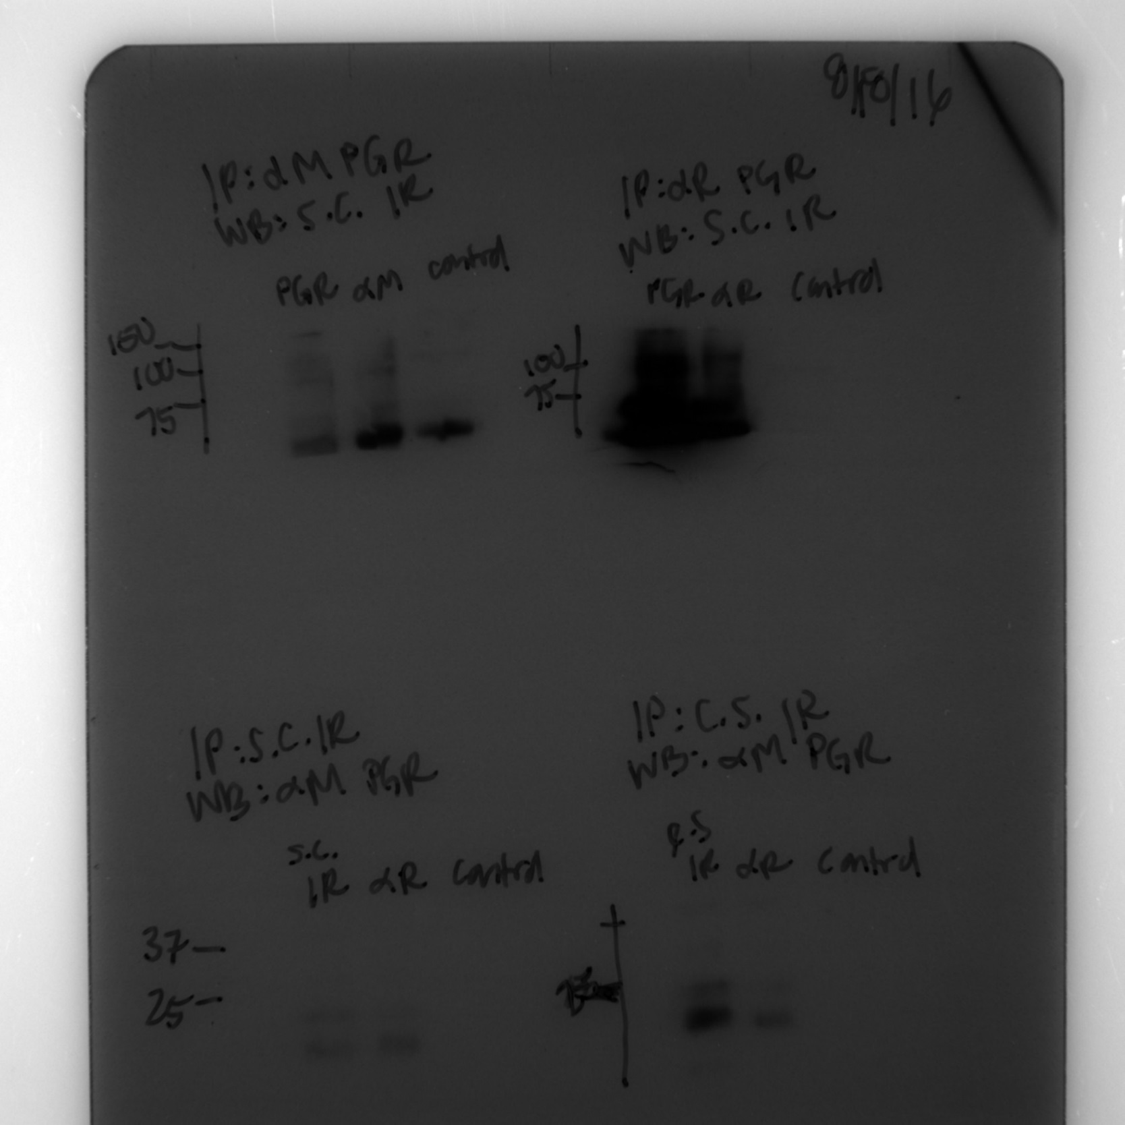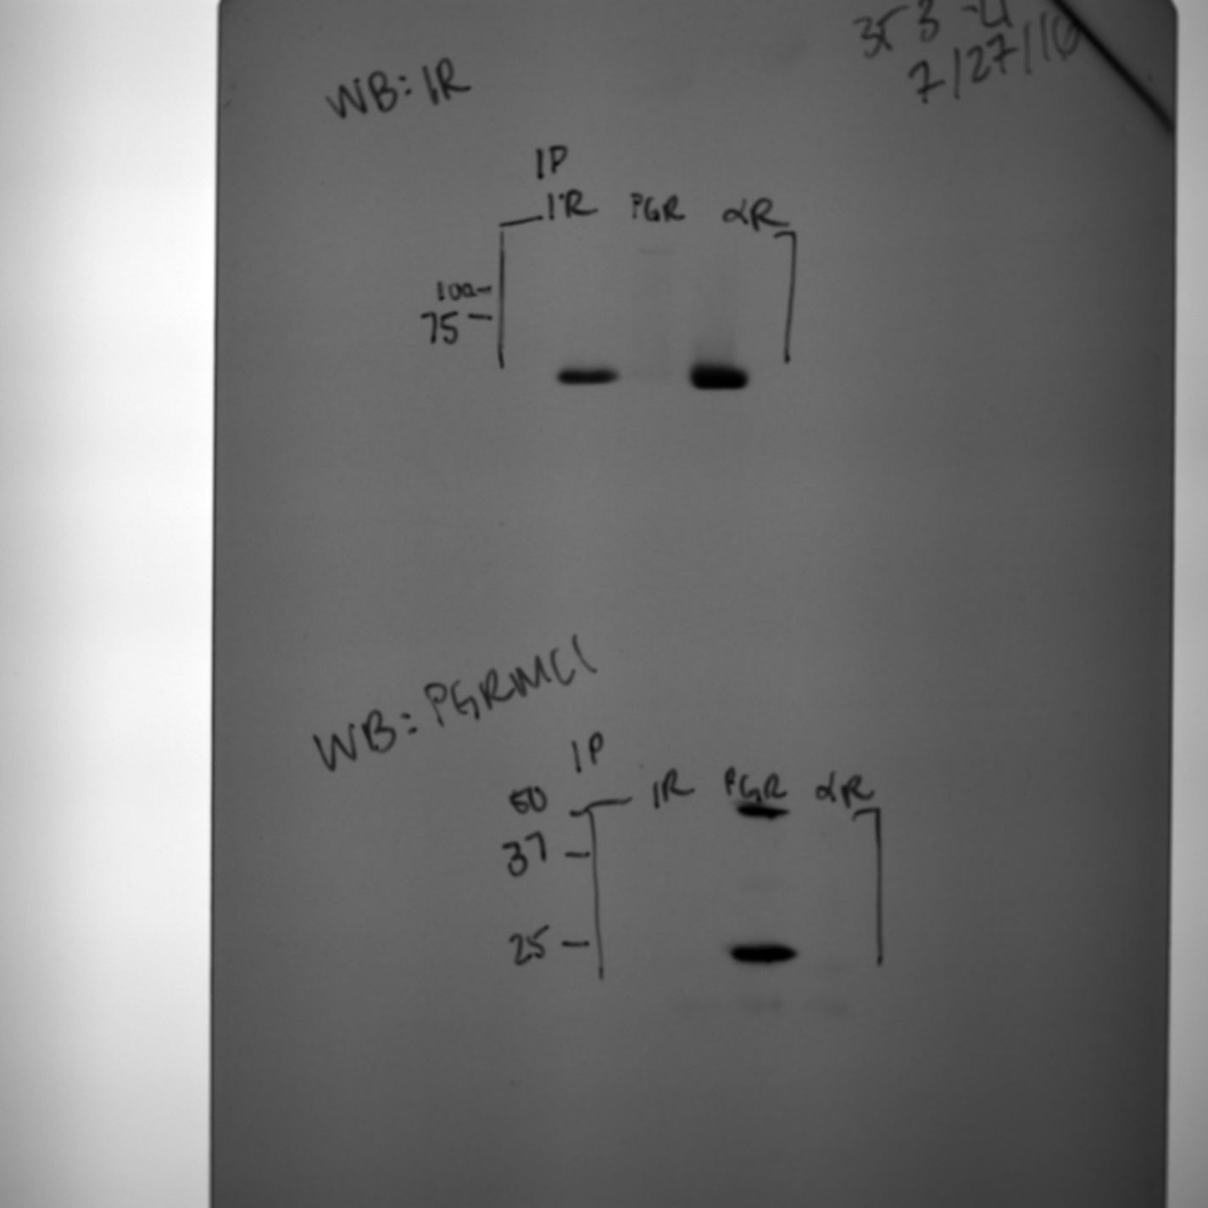

**IP: IR**

**WB: PGRMC1**

**IP: PGRMC1**

**WB: PGRMC1**