EPIC FAQs for Study Teams

Application Vendor and Version:
Current version can be found by logging into Epic and clicking on the “Epic Log” in the upper left corner. Then click on “About Hyperspace”.
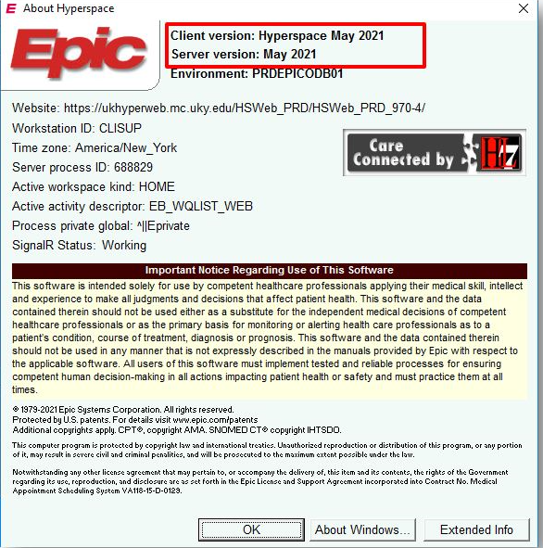
External Research Study Monitors:
- UKHC can now use external research monitors to complete remote study audits.
- External monitors are required to submit a request for a UKHC LinkBlue ID as well as an EpicCare Link access request.
  - Both have to be completed before an external monitor can have access to any patient charts.
- Monitors are granted access to specific patients on specific studies for up to 5 days at a time within the hours of 8am-5pm EST.
- Audit trails can be performed to monitor what patient information was viewed by the external monitors.

EPIC is ONC certified:
How do you find information about Epic ONC Certification?
General information about Epic’s software ONC certifications is available on our website and ONC's Certified Health IT Product List (CHPL) website.
We are careful to include this certification information when our certification status is referenced because we want to be transparent on certification details and what software is and is not certified. Being clear with certification details is also required by the marketing guidelines of the certification program. If you ever reference the certification status of Epic's software--for example, in an application for a grant, or in information you provide to Connect affiliates--you are expected to exercise similar precision and to include a link to the detailed information on Epic's website at www.epic.com/mu.
If you have a question about our current certifications that isn’t answered by those sources or this article please reach out to your Epic representative so we can be sure to help you find the information you’re looking for.

