Register at the CastleBranch website: https://uky-com.castlebranch.com/UO23
Click on “PLACE ORDER” at the bottom of the page.

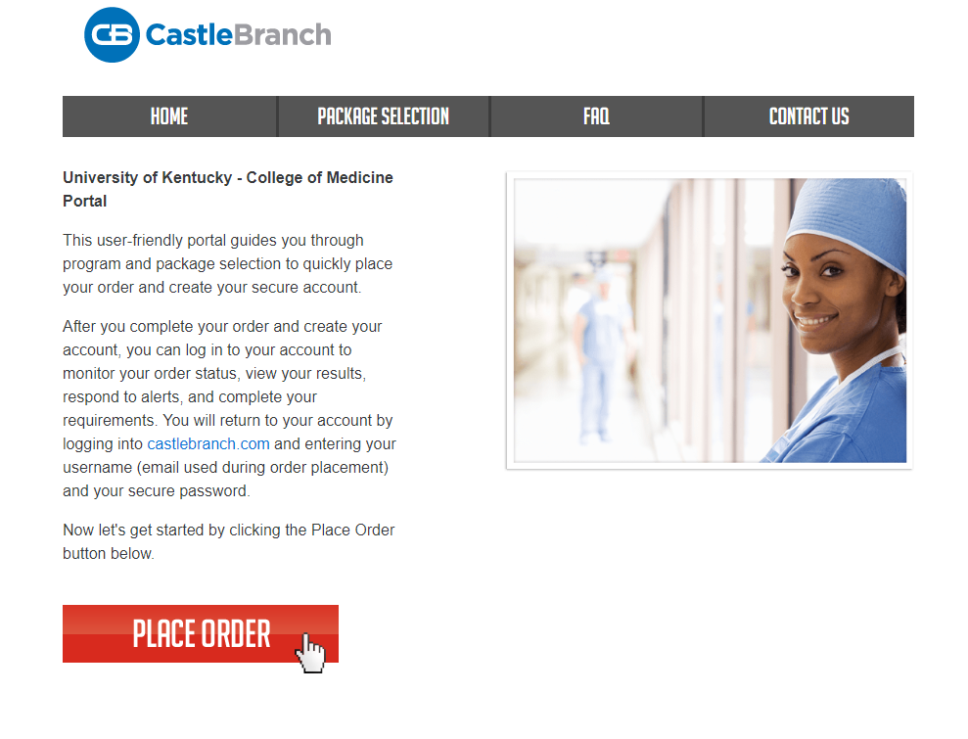

Click on “Please Select” and then click on “UO23: I need to order my initial Drug test and Medical Document Manager”
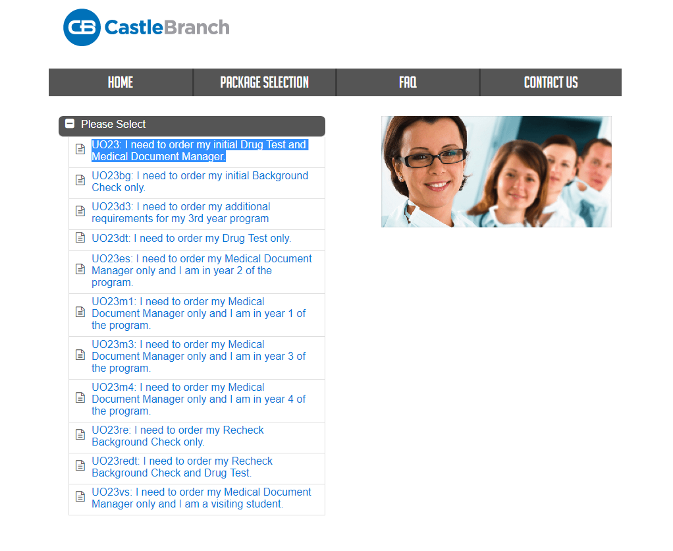

After selecting “UO23: I need to order my initial Drug test and Medical Document Manager”, you will see the screen below. Read the details. Click the box to accept the terms and agreement. Then select “Click to Continue” at the bottom of the page.
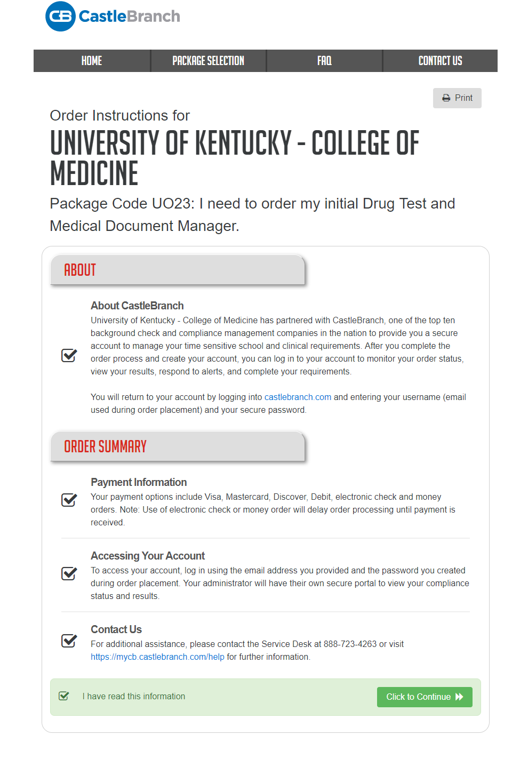
After pressing “Click to Continue”, you will see the screen below, which asks you to review information. Review information and select the box confirming you have read and agreed to the terms and conditions. Then select “Continue” at the bottom of the page.

After pressing “Continue”, you will see the screen below, which asks for information for you to provide. Provide the information and then click next at the bottom of the right page. At the top of the page below, you will see that there are nine steps to place your order. Submit the information requested on each page/step. Then click “Next” until all steps and your order is complete.

